Assignment – 03

# Name – Md. Farhan Ishmam

# Student ID – 180041120

# Department – Computer Science and Engineering

# Course Number - EEE 4484

# Experiment No. - 03

# Task – 2

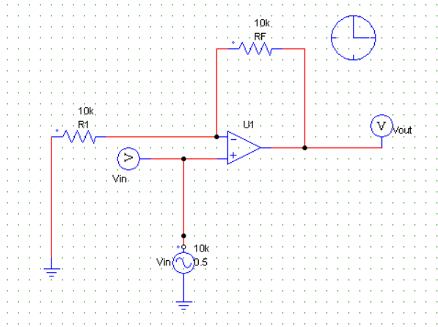

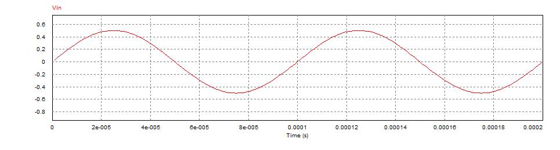

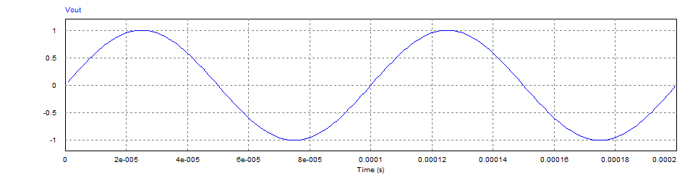

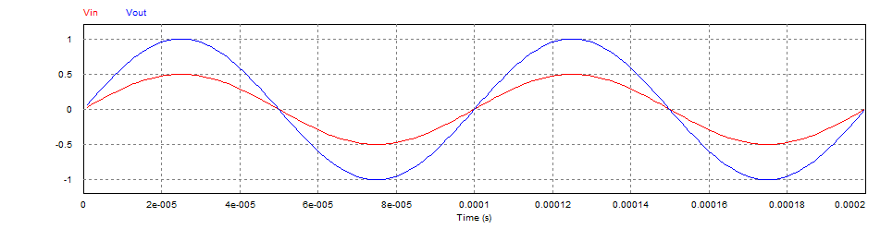

# Task - 3

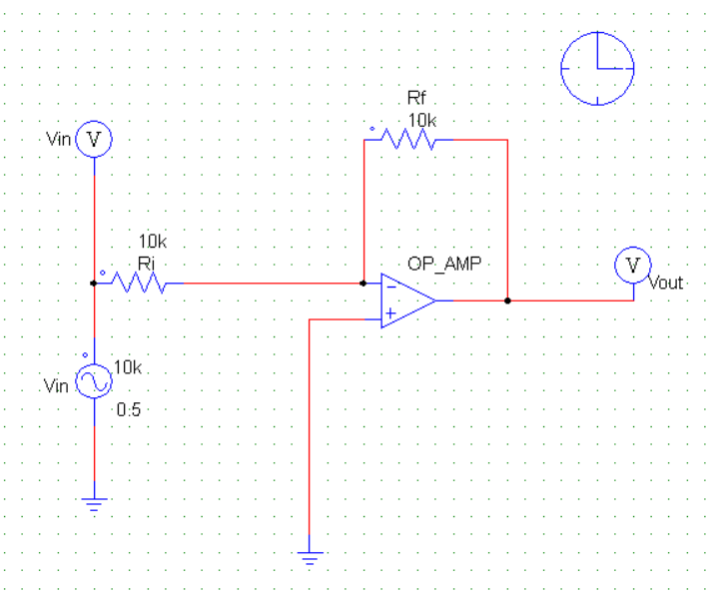

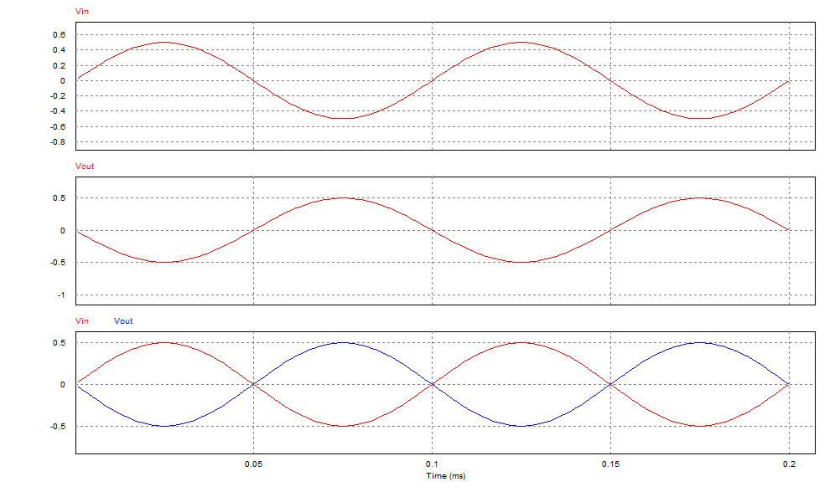

# Task - 4

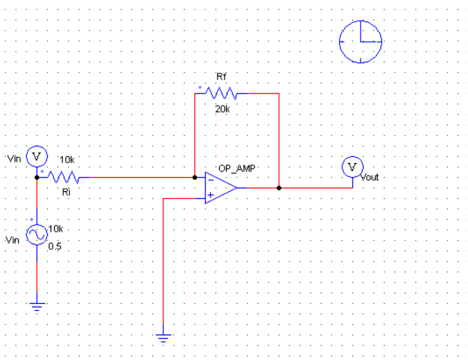

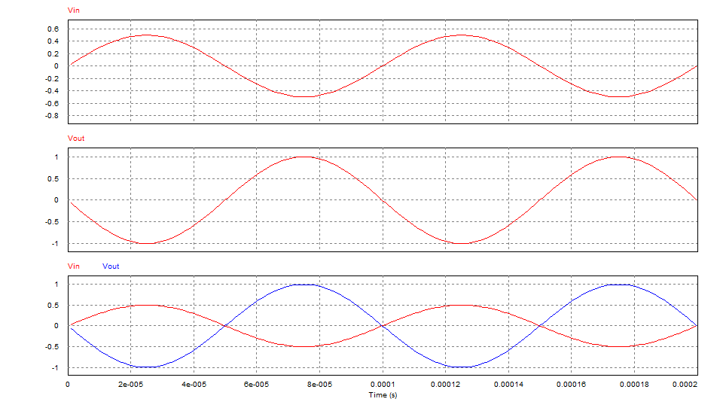

The input peak voltage is increased to 8V and the graph is taken. **At any input peak voltage greater than 7.5 volt, output clipping occurs**. Because the power supplied to the amp is +15 and -15. So, output voltage must be within this range. The op-amp amplifies the signal by 2 times. So, when input peak voltage is more than 7.5 V, output peak voltage become more than 15 V. The op-amp is unable to create waves greater than the supplied power and so, the output wave is clipped.

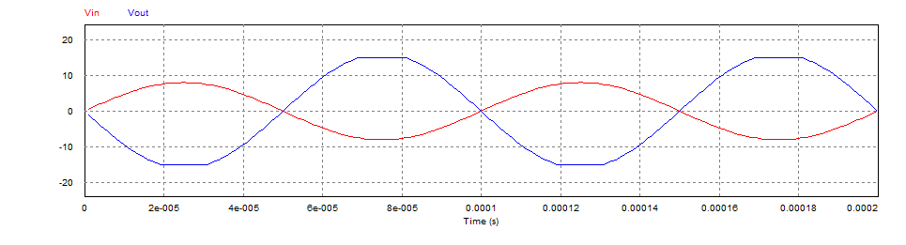

# Task – 5

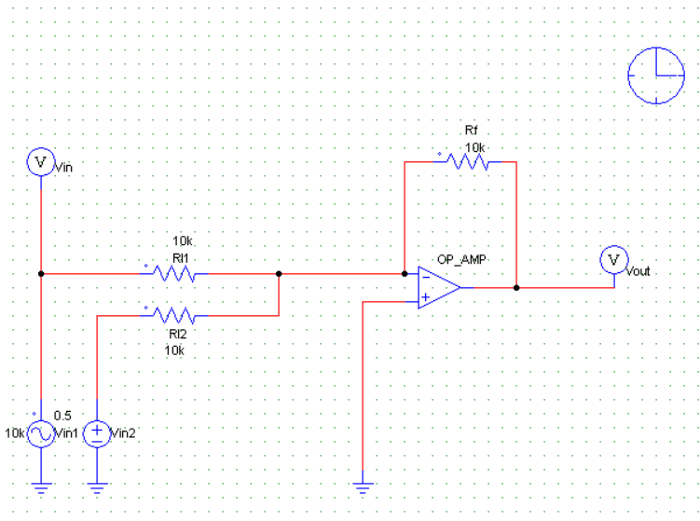

**When Vin2 = 0V**

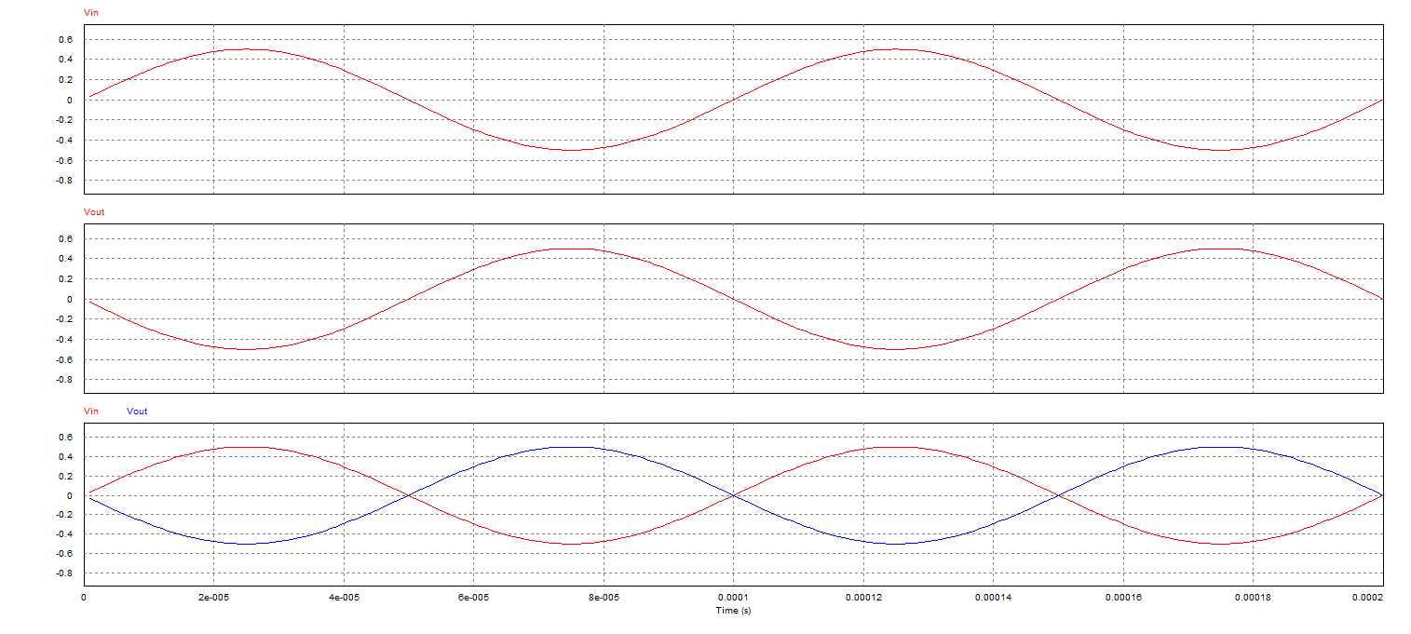

**Vin2 = 5V**

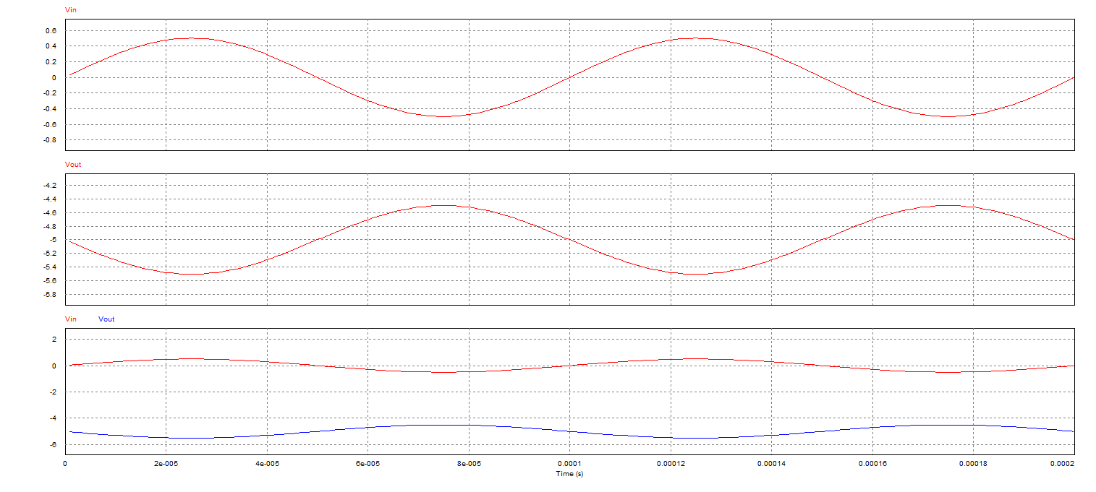

**Vin2 = -5V**

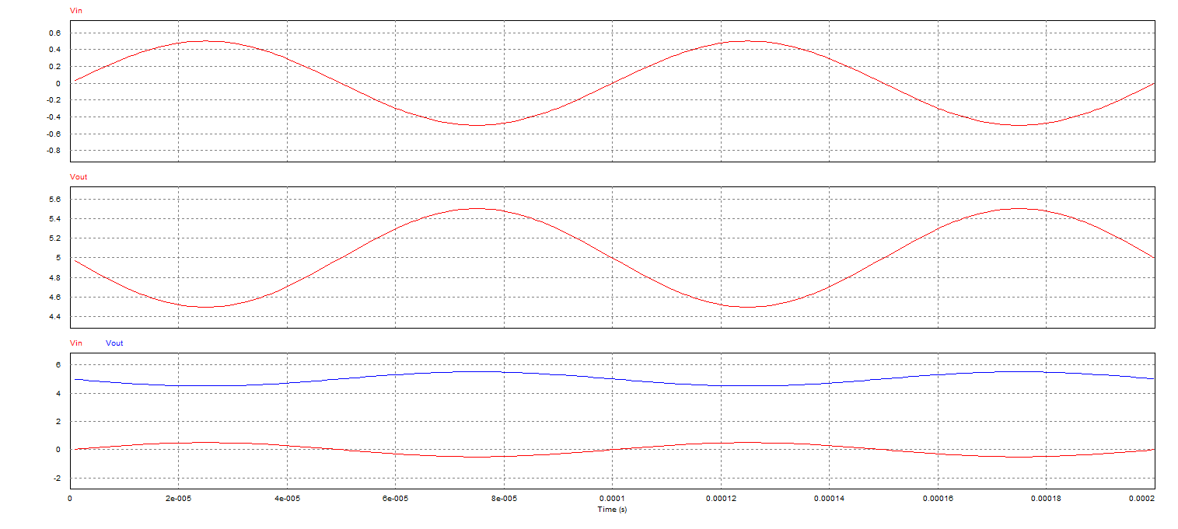

# Task – 6

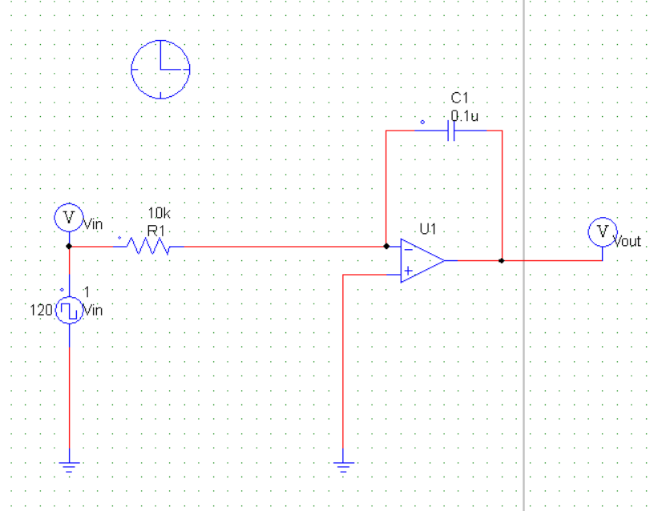

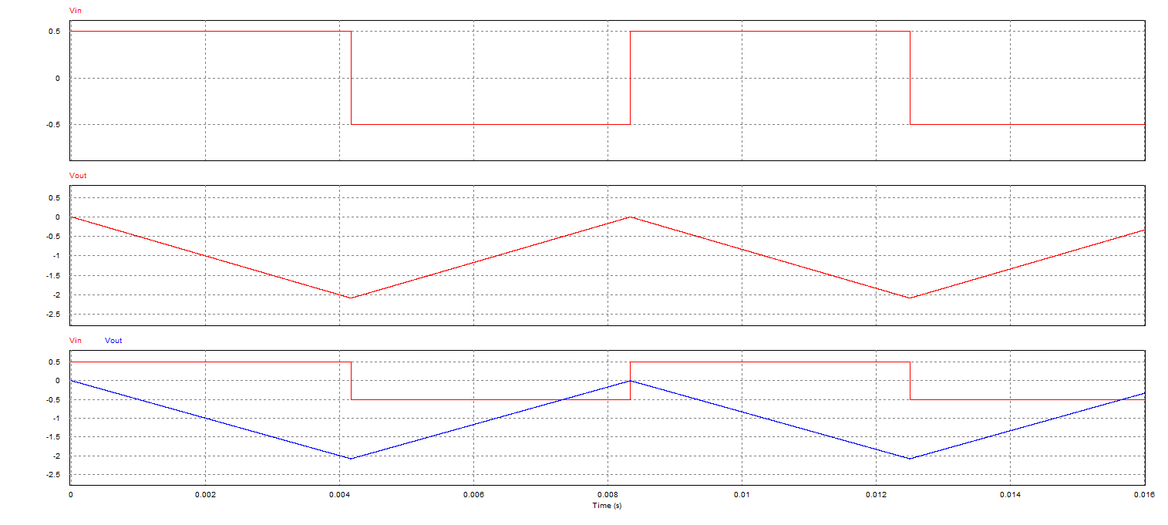

# Task – 7

